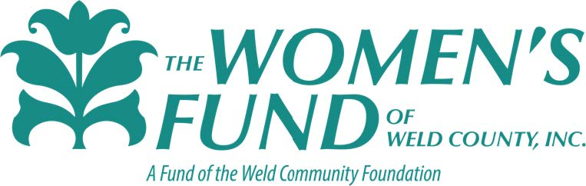

News Release

Women’s Fund of Weld County, Inc. .-358

For Immediate Release
CONTACT: Carrie Walker
President
970-381-7081
Women’s Fund of Weld County Opens 2021 Grant Cycle

Greeley, Colo., June 27, 2021—The Women’s Fund of Weld County today announced the opening of the 2021 Grant Cycle. Grant applications are now being accepted for non-profit organizations that address unmet needs of women and girls in Weld County.

“In 2020, the Women’s Fund awarded over $33,000 in grants to local non-profits with programs that support our mission,” said Carrie Walker, President of the Women’s Fund of Weld County. “We are honored to have the opportunity to help improve the lives of women and girls in Weld County. And, in 2021, we are pleased to announce the additional option of offering grants to qualifying non-profits to cover operating expenses for the 2021 grant cycle.”

Non-profit organizations (501(c)(3)), or groups within these organizations are encouraged to apply. The submission deadline is August 31, 2021.

Please visit our website at www.weldwomensfund.org to learn more about the criteria, application requirements and to apply. Grants for this cycle will be from $500 to $5,000 and applicants will be notified by October 1, 2021, if they have been approved.

About The Women’s Fund
The Women’s Fund of Weld County, Inc. was founded in 1999 by women from the community dedicated to improving the lives of women and girls. The Women’s Fund, a charitable fund of the Weld Community Foundation, was established with the purpose of creating a permanent fund to find, fund and nurture programs that address unmet needs of women and girls in Weld County to enable them to become self-confident, independent, contributing members of the community. Over the life of the fund, more than $377,000 has been awarded from The Women’s Fund to Weld County organizations.

- end -

